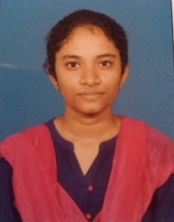

**Yamini Lalitha sri Gudapati**



Name

Yamini Lalitha sri Gudapati

Designation

Software Engineer

Personal Details .

|  |  |
| --- | --- |
| Birth Date | 31/08/2001 |
| Residence | Andhra Pradesh, East Godavari |
| Nationality | Indian |
| Marital Status | Single |
| Gender | Female |
|  |  |
|  |  |
|  |  |

Profile

.

|  |  |
| --- | --- |
|  |  |
| Designation : | Analyst A4 |
| BU : | Insights & Data |
| DOJ : | 22nd Dec, 2022 |
| Service Line : | I&D DM |

Competenc

i

es

.

Languages : Java, AWS Cloud, Spring Boot

Environment : Eclipse-IDE

Database : PostgreSQL

Internet Tools : Postman

Languages

.

|  |  |  |  |
| --- | --- | --- | --- |
| Languages | Speak | Read | Write |
| English | Fluent | Fluent | Fluent |
| Telugu | Fluent | Fluent | Fluent |

1



|  |  |  |  |  |  |
| --- | --- | --- | --- | --- | --- |
| **Yamini Lalitha sri** | | | | |  |
| **SKILLS SET :** | | | | |
| **Domain Experience**     |  |  | | --- | --- | | Mini Project | Multiplex Booking System | | Tools &  Technologies | Spring Boot,  PostgreSQL, GitHub, Postman | | Description | A multiplex is a movie theatre complex having multiple screens to screen the movies. Many movies can run on these screens simultaneously during various time slots of a day |         **Education :** | | | | |
|  | **EXAMINATION** | **YEAR** | **PERCENTAGE SECURED** | **INSTITUTION** | |
| B -Tech  Mechanical Engineering | 2022 | 78% | RGUKT - Nuzvid | |
| P.U.C | 2018 | 82% | RGUKT - Nuzvid | |
| 10th | 2016 | 98% | ZPH School,  Brahmanagudem | |
| Add Address : H.No – 1-151, Sivalayam Street, Kalavalapalli village, Chagallu, East Godavari , Andhra Pradesh, 534301  Mobile Number : 9642824417  Cor Corporate Email : yamini-lalitha-sri.gudapati@capgemini.com    2 | | | | |